Excursion to NSW Schoolhouse Museum of Public Education
Updated 11 March 2024
Risk assessment focus: Excursion to NSW Schoolhouse Museum of Public Education, located on the grounds of North Ryde Public School
NOTE: This document is provided by the NSW Schoolhouse Museum of Public Education as advice to assist teachers in their risk management planning for their excursion to the NSW Schoolhouse Museum that a visiting school may wish to incorporate into their risk management process. It includes infection control for COVID-19,
The proforma has been downloaded from the NSW Department of Education’s Health and Safety Directorate (DoE staff only) and has been populated by the NSW Schoolhouse Museum’s education officers who are NSW Department of Education employees.

Situation | Anticipate | Find out |  | Eliminate or control |  | Talk to others | You
List the details of the activity, event or task | What could go wrong? | What current controls are in place? | Risk rating | What else can be done to control this risk? | Residual risk rating | Controls to be actioned by who? | When do you need to review the control?
Medication and health of visiting adults and students and museum staff | Infection from COVID-19 (Novel Coronavirus) | Ongoing reference is made to the most current NSW Department of Education COVID-19 advice  Museum and school staff, adults and students who are unwell with flu-like and/or respiratory symptoms are not to attend the excursion.  Museum and school staff, adults and students who have tested positive on a RAT or PCR test to COVID-19, or have COVID-19 symptoms, are not to attend the excursion program.  All students, staff and visitors to wash hands with soap and water or use hand sanitizer at appropriate times.  Surfaces and objects used by students and adults to be cleaned at appropriate times.  If any staff, adults or students become unwell with respiratory symptoms, isolate from others and arrange for collection. | 4 | Visiting teachers and NSW Schoolhouse Museum provide hand sanitizer.  High touch surfaces will be cleaned at appropriate times.  Maximise ventilation and cross-ventilation by opening windows and doors on opposite and adjacent sides of the rooms even when heaters and air conditioners are on.  Museum staff, visiting adults and children are supported to wear masks if they choose to.  Visiting school students, teachers and adults stay within defined areas on the site to avoid contact with North Ryde PS staff and students.  Hygiene practices implemented during the toasting activity by adults and students. |  | School excursion co-ordinator  School class teachers  Other visiting adults accompanying the school students  Schoolhouse Museum staff | Before leaving school on the excursion  Before students arrive  During excursion program  After the excursion program
 | Spreading of illnesses | Museum and school staff, adults and students who are unwell are not to attend the excursion program. | 4 | If any staff, adults or students unexpectedly become unwell with respiratory, gastric or other contagious illness, isolate from others and arrange for collection. |  | School excursion co-ordinator  Other visiting adults accompanying the school students  Schoolhouse Museum staff | Before leaving school on the excursion  Before students arrive
 | Adverse effects of not taking prescribed medications | School staff responsible for administering medication to students bring medications and have appropriate training. | 5 | School staff to notify Schoolhouse Museum staff of particular medical needs of students that may impact their involvement in the excursion program. |  | School class teachers  School support staff | Before the excursion  During excursion program
Bus transport to and from the site | Accidents boarding or disembarking from the coach and walking to the museum entrance | Bus to park at the marked bus stop 20 metres from entrance gate on southern side of the road (museum side).  Students to walk along footpath from bus stop to gate.  School staff to supervise and support students disembarking from the bus, walking along path and boarding onto bus. | 5 | Enforce rules and monitor behaviour.  Share the Schoolhouse Museum’s social story with students that explains student travel and movement.  Activate student behaviour support plans  Do not embark or disembark the bus if it stops in the ‘no parking’ or ‘no stopping’ zones outside the museum. |  | School class teachers | On arrival at and departure from site
 | Vehicle accident | Ensure vehicle operator holds appropriate licence and insurance  Check availability of seatbelts  Ensure seatbelts, if available, are worn | 2 | Check that bus driver is familiar with the destination and route  Do not embark or disembark the bus if it stops in the ‘no parking’ or ‘no stopping’ zones outside the museum. |  | Excursion co-ordinator  School class teachers | During bus booking  During travel to and from excursion
Staff qualifications and training | Staff not having appropriate qualifications or training | All Schoolhouse Museum staff are NSW Department of Education employees who hold current mandatory training certificates including CPR, e-Emergency Care, anaphylaxis  Visiting school staff are CPR qualified and trained in anaphylaxis and emergency care.  All museum staff hold a current WWC check as a requirement of DoE employment. | 6 | At least one museum, school, visiting staff member or staff member on the school site should hold a current Fist Aid certificate.  Museum staff update their mandatory training as required. |  | Schoolhouse Museum staff  School class teachers | Before excursion
Emergency response | Injury resulting from an emergency situation | Emergency response maps for evacuation and lock-down shown and explained to visiting staff on arrival, displayed in the museum rooms and a copy in each outdoor activity kit.  Museum staff and visiting school staff and students must abide with North Ryde Public School’s emergency procedures.  Step-by-step emergency response actions for museum staff are on the desk in each indoor space and in each outdoor activity kit.  Museum staff regularly review and update emergency response procedures.  Museum staff undertake regular emergency response drills. | 5 | Museum staff regularly liaise with North Ryde Public School school staff in relation to emergency procedures.  All visiting adults accompanying school excursions to sign in via the Museum’s QR code sign-in to generate a list of adults present.  Museum registration QR code provides digital access to the emergency map and procedures.  Museum staff to carry mobile phones at all times to enable contact among staff during an emergency |  | Schoolhouse Museum staff  School class teachers  School support staff  North Ryde Public School principal | Before excursions  During excursions
Weather conditions and air quality | Injury or ill health due to extreme heat, cold, wind, dust storm or bushfire smoke | Undertake alternative activities indoors to minimize exposure to the extreme weather elements outside.  Use solid shaded areas for outdoor activities when hot and minimize physical exertion.  Staff and students to wear sun hats and appropriate PPE to minimize exposure.  On hot days, modify the day’s timetable to avoid the heat in the middle of the day.  On cold days, modify the program to warm up the students with physical activity in the morning. | 5 | Minimise exposure to the elements.  Monitor the wellbeing of students, staff and adults and modify the excursion activities program as needed.  Provide drink breaks as needed.  On hot days, provide ready access to water for refilling drink bottles. |  | Schoolhouse Museum staff  School class teachers  School support staff | Before excursion program  During excursion program
Movement between activity sites | Vehicles using school driveway or car park | Access lunch area and toilets via western end of building and western edge of car park within marked lines.  Manage student movement and assembly so as to avoid vehicles. | 5 | The carpark is only accessed by a coded boom gate. School deliveries use an alternative vehicle entry. |  | Schoolhouse Museum staff  School class teachers  School support staff | During excursion
Excursion program and activities | Needing to access toilets during sessions | Students to always be accompanied by an adult to the toilet block.  Students to go in pairs, accompanied by an adult, to the toilets near ODAC shelter. | 5 | Encourage use of toilets before the start of the program.  Access the ODAC toilets via the marked walkway at the western edge of the carpark. |  | Class teachers  School support staff | During excursion
 | Tripping up and down steps into, out of and within the building | Advise students that there are steps and to take care.  Supervise entry into and exit from the building.  Steps marked with tape or labels.  Manage student movement to prevent rushing or pushing. | 5 | Monitor student behaviour. |  | Schoolhouse Museum staff  School class teachers and staff | During excursion
 | Student behaviours that cause damage to museum property or harm to others | Class teachers and school support staff anticipate and manage student behaviours  Excursion plan sent to excursion co-ordinator who forwards it to all accompanying staff  All visiting school staff read the excursion plan and prepare students as appropriate  Visiting staff to be familiar with individual student behaviour support plans |  | Class teachers to remain with their class at all times  Class teachers and students view the ‘About the Schoolhouse Museum’ video and social story on the About the Schoolhouse Museum page of the Pre and Post Visit learning resource. |  | Class teachers  School support staff  Schoolhouse Museum staff | Before excursion  During excursion
 | Bites and stings from insects such as bees, wasps, spiders, including anaphylaxis or allergic reaction | (High risk only in the case of anaphylaxis)  Keep grass mown – managed by school’s gardener or general assistant  Check for wasp nests and bee swarms and relocate activity if hazard is present.  EpiPen® and ice pack in First Aid cupboard in museum kitchen.  Ice packs in each outdoor activity first aid kit.  All museum staff trained in anaphylaxis procedures. | 3/4 | Students diagnosed as being at risk of anaphylaxis have ASCIA Action Plan for Anaphylaxis and adrenaline auto-injector carried by classroom teacher.  Class teachers and staff supervise students during recess and lunch so that they stay within defined boundaries and mowed grass areas |  | Schoolhouse Museum staff  School class teachers and staff | Before excursion  During excursion
 | Grazes or injuries from falls when skipping, running and jumping outside | Check and clear ground of trip hazards such as sticks.  Locate maypole and games on even ground.  Instruct students on how to skip around maypole safely.  Manage spacing and movement of students to avoid collisions.  Locate equipment and manage student movement to minimise trips and falls.  First aid supplies on hand. | 4 | Do not run games and maypole dancing in the rain or if the ground is very wet or slippery.  Manage movement of the students |  | Schoolhouse Museum staff  School class teachers  School support staff | Before excursion  During excursion
 | Injuries from equipment such as wands, quoits, skipping rope, ink pens, darning needles | Manage spacing of students using pre-marked spots and other markers  Demonstrate and provide explicit instructions and demonstrate correct handling of equipment  Manage student movement to avoid collisions  Supervise use of equipment  First aid supplies on hand | 5 | Modify activity if students exhibit dangerous behaviours whilst using equipment |  | Schoolhouse Museum staff  School class teachers  School support staff  Accompanying adult assistants
 | Smoke inhalation or burns from open fires used for heating  (Fires used only in cool weather, usually Terms 2 and 3) | Ensure fire screens are in place throughout sessions when fire is not in use for toasting  Manage students in 1877 room to avoid the fire  Ready access to fire blanket, bucket of water and fire extinguisher  If smoky, remove asthmatic students until smoke clears  Ventolin reliever and spacer in First Aid cupboard in kitchen  All museum staff trained in emergency asthma management | 3 | Light fires early to minimise smoke when students enter room  Open windows to create cross ventilation |  | Schoolhouse Museum staff
 | Burns from toasting bread over an open fire  (Toasting activity only in cool weather, usually Terms 2 and 3) | Screen fires with fire screens when not in use for toasting  Toasting activity to only proceed under the continuous and constant supervision of two adults who have been briefed on procedures  Brief parent helpers on toasting and safety procedures  Give explicit instructions and demonstrate use of toasting equipment  Students to be seated at all times whilst at the fire toasting  Limit of two students toasting, seated at the fire, and two students waiting to toast, seated behind the two toasting  Ready access to fire blanket, bucket of water and fire extinguisher | 3 | Prevent students queuing at fire by redirecting them to other activities  Check for highly flammable clothing or accessories being worn by students and adult fire supervisors.  Provide calico aprons to cover highly flammable skirts.  Remove flammable accessories such as knitted shawls.  Send link to Briefing for Toasting Video for adult helpers to view before arrival. |  | Schoolhouse Museum staff  School class teachers  School support staff  Accompanying adult assistants
 | Allergies to wheaten bread or golden syrup in toasting activity | Prior to excursion, the excursion organiser to notify museum staff of potential food allergies and most appropriate management strategy  Students have the option to bring their own bread to toast  Ensure clean and non-contaminated equipment and surfaces are used for students with allergies to bread ingredients  Have packet available that lists ingredients of golden syrup and bread | 5 | Students with coeliac disease to be in the first group in 1910 room and be the first to toast so that equipment is clean and uncontaminated  List of bread and golden syrup ingredients on Schoolhouse Museum website |  | Schoolhouse Museum staff  School class teachers  Accompanying adult assistants
 | Injury from unstable fencing or building materials during maintenance and construction works on site | Safety fencing installed around scaffolding, building works and equipment storage areas  The contractor’s WHS management plan, SWMS and associated safety permits to cover all risk management and protocols required to create a safe working environment. | 4 | Manage student movement and assembly to maintain safe travel and building access |  | Schoolhouse Museum staff  School class teachers  School support staff | During excursion

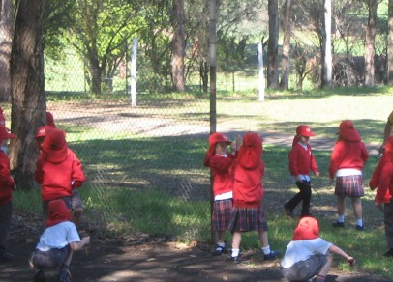 | 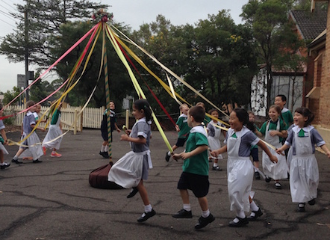 | 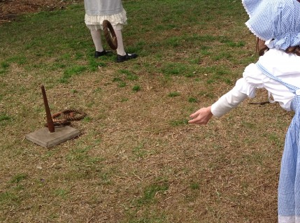 | 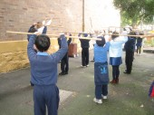 | 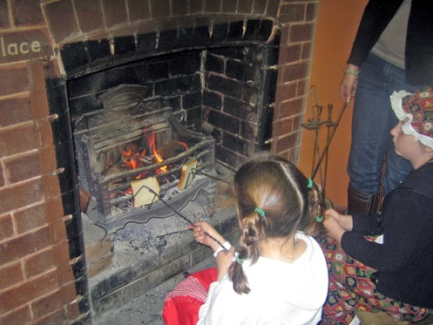
Playground - lunchtime and recess | Maypole dancing | Playing quoits | Wand drill using wands (poles) | Toasting bread over open fire | Writing with an ink pen

Risk rating matrix
Consequence criteria  How serious would it be | Likelihood criteria  How likely is it to occur
 | Very likely | Likely | Unlikely | Very unlikely
Extreme | 1 | 1 | 2 | 3
High | 1 | 2 | 3 | 4
Medium | 2 | 3 | 4 | 5
Low | 3 | 5 | 5 | 6

