At School At War Excursion to NSW Schoolhouse Museum of Public Education
Updated 8 March 2021
Risk assessment focus: Excursion to NSW Schoolhouse Museum of Public Education, located on the grounds of North Ryde Public School
NOTE: This proforma is provided by the NSW Schoolhouse Museum of Public Education as advice to assist teachers in their risk management planning for their excursion to the NSW Schoolhouse Museum, including Infection control for COVID-19, that a visiting school may wish to incorporate into their risk management process.
The proforma has been downloaded from the NSW Department of Education’s Health and Safety Directorate (DoE staff only) and has been populated by the NSW Schoolhouse Museum’s education officers who are NSW Department of Education employees.

Situation | Anticipate | Find out |  | Eliminate or control |  | Talk to others | You
List the details of the activity, event or task | What could go wrong? | What current controls are in place? | Risk rating | What else can be done to control this risk? | Residual risk rating | Controls to be actioned by who? | When do you need to review the control?
Medication and health of visiting adults and students and museum staff | COVID-19 pandemic –  infection of COVID-19 | Ongoing reference is made to the most current NSW Department of Education COVID-19 advice (includes link to advice for NSW DoE staff)  Museum and school staff, adults and students who are unwell with respiratory illness are not to attend the excursion program.  Museum and school staff, adults and students who have been in contact with a known COVID-19 case, are awaiting COVID-19 test results or have been directed or advised to self-isolate are not to attend the excursion program.  All adults on site are to practise physical distancing of 1.5m.  All students, staff and visitors to wash hands with soap and water or use hand sanitizer on-site immediately before eating, at the commencement of each session and at the program conclusion.  Surfaces and objects used by students and adults to be cleaned at appropriate times during and after the program.  If any staff, adults or students become unwell with respiratory illness, isolate from others and arrange for collection. | 4 | Visiting teachers and NSW Schoolhouse Museum provide hand sanitizer.  Students bring personal hand sanitizer.  All visiting adults will be required to sign in and acknowledge that they will comply with the NSW Department of Education’s COVID-19 requirements for visitors to school sites. This will be done digitally via a QR code. All visiting adults must also check in using the Service NSW QR code.  High touch surfaces in the toilet block shared with the North Ryde PS OOSH students will be cleaned prior to and after use by visiting students. This also applies to the museum’s staff toilet and kitchen areas used by visiting adults.  Where possible during the program, minimise objects shared by students.  Museum staff to minimize physical contact with visiting students.  Students keep their drink bottles in their bags or with them instead of class storage tubs. |  | School excursion co-ordinator  School class teachers  Other visiting adults accompanying the school students  Schoolhouse Museum staff | Before leaving school on the excursion  Before students arrive  During excursion program  After the excursion program
 | Spreading of illnesses | Museum and school staff, adults and students who are unwell are not to attend the excursion program. | 4 | If any staff, adults or students unexpectedly become unwell with respiratory illness, isolate from others and arrange for collection. |  | School excursion co-ordinator  Other visiting adults accompanying the school students  Schoolhouse Museum staff | Before leaving school on the excursion  Before students arrive
 | Adverse effects of not taking prescribed medications | School staff responsible for administering medication to students bring medications and have appropriate training. | 5 | School staff to notify Schoolhouse Museum staff of particular medical needs of students that may impact their involvement in the excursion program. |  | School class teachers  School support staff | Before the excursion  During excursion program
Bus transport to and from the site | Accidents boarding or disembarking from the bus/coach and walking to the museum entrance | Bus to park at the marked bus stop 20 metres from entrance gate on southern side of the road (museum side).  Students to walk along footpath from bus stop to gate.  School staff to supervise and support students disembarking from the bus, walking along path and boarding onto bus. | 5 | Enforce rules and monitor behaviour.  Provide a social story that explains student travel and movement. |  | School class teachers | On arrival at and departure from site
Staff qualifications and training | Staff not holding appropriate qualifications | All Schoolhouse Museum staff are NSW Department of Education employees who have hold current mandatory training certificates including CPR, e-Emergency Care, anaphylaxis  Visiting school staff are CPR qualified and trained in anaphylaxis and emergency care.  All museum staff hold a current WWC check as a requirement of DoE employment. | 6 | At least one museum, school or visiting staff member should hold a current Fist Aid certificate.  Museum staff check and update their mandatory training as required. |  | Schoolhouse Museum staff  School class teachers | Before excursion
Emergency response | Injury resulting from an emergency situation | Emergency response maps for evacuation and lock-down shown and explained to visiting staff on arrival, displayed in the museum rooms and a copy is in each outdoor activity kit.  Museum staff and visiting school staff and students must abide with North Ryde Public School’s emergency procedures.  Step-by-step emergency response actions for museum staff are on the desk in each indoor space and in each outdoor activity kit.  Museum staff undertake regular emergency response drills. | 5 | Museum staff regularly review and update emergency response procedures.  Museum staff regularly liaise with North Ryde Public School school staff in relation to emergency procedures. |  | Schoolhouse Museum staff  School class teachers  School support staff  North Ryde Public School principal | Before excursions  During excursions
Weather conditions and air quality | Injury or ill health due to extreme heat, cold, wind, dust storm or bushfire smoke | Undertake alternative indoor activities to minimize exposure to the extreme weather elements outside.  Use solid shaded areas for outdoor activities when hot and minimize physical exertion.  Staff and students to wear appropriate PPE to minimize exposure.  Provide drink breaks as needed.  On hot days, modify the day’s timetable to avoid the heat in the middle of the day.  On cold days, modify the program to warm up the students with physical activity in the morning. | 5 | Minimise exposure to the elements.  Monitor the wellbeing of students, staff and adults and modify the excursion activities program as needed. |  | Schoolhouse Museum staff  School class teachers  School support staff | Before excursion program  During excursion program
Movement between activity sites | Vehicles using school driveway or car park | Access lunch area and toilets via western end of building and western edge of car park within marked lines.  Manage student movement and assembly so as to avoid vehicles. | 5 | The carpark is only accessed by a coded boom gate. School deliveries use an alternative vehicle entry. |  | Schoolhouse Museum staff  School class teachers  School support staff | During excursion
Excursion program and activities | Needing to access toilets during sessions | Students to always be accompanied by an adult to the toilet block.  Students to go in pairs, accompanied by an adult, to the toilets near ODAC shelter. | 5 | Encourage use of toilets before the start of the program. |  | Class teachers  School support staff | During excursion
 | Tripping up and down steps into, out of and within the building | Advise students that there are steps and to take care.  Supervise entry into and exit from the building.  Steps marked with tape or labels.  Manage student movement to prevent rushing or pushing. | 5 | Monitor student behaviour. |  | Schoolhouse Museum staff  School class teachers | During excursion
 | Bites and stings from insects such as bees, wasps, spiders, including anaphylaxis or allergic reaction | (High risk only in the case of anaphylaxis)  Keep grass mown – managed by school’s GA  Check for wasp nests and bee swarms and relocate activity if hazard is present.  EpiPen® and ice pack in First Aid cupboard in museum kitchen.  Ice packs in each outdoor activity first aid kit.  All museum staff trained in anaphylaxis procedures. | 3/4 | Students diagnosed as being at risk of anaphylaxis have ASCIA Action Plan for Anaphylaxis and adrenaline auto-injector carried by classroom teacher. |  | Schoolhouse Museum staff  School class teachers | Before excursion  During excursion
 | Grazes or injuries from falls when marching, doing physical drill outside or undertaking organized games | Check and clear ground of trip hazards such as sticks.  Manage spacing and movement of students to avoid collisions.  Provide explicit instructions on actions and movement.  Remain of flat surfaces if possible.  First aid supplies on hand. | 4 | Manage student movement around building  Do not use, or modify activities, to avoid slippery surfaces |  | Schoolhouse Museum staff  School class teachers  School support staff | Before excursion  During excursion
 | Injuries from equipment such as ink pens, scissors, semaphore flags | Manage spacing of students using pre-marked spots and other markers  Demonstrate and provide explicit instructions and demonstrate correct handling of equipment  Manage student movement to avoid collisions  Supervise use of equipment  First aid supplies on hand | 5 | Modify activity if students exhibit dangerous behaviours whilst using equipment |  | Schoolhouse Museum staff  School class teachers  School support staff  Accompanying adult assistants
 | Smoke inhalation or burns from open fires used for heating  (Fires used only in cool weather, usually Terms 2 and 3) | Ensure portable fire screen is in place throughout sessions  Manage students in 1877 room to avoid the fire  Ready access to fire blanket, bucket of water and fire extinguisher  If smoky, remove asthmatic students until smoke clears  Ventolin reliever and spacer in First Aid cupboard in kitchen  All museum staff trained in emergency asthma management | 3 | Light fires early to minimise smoke when students enter room  Open windows to create cross ventilation |  | Schoolhouse Museum staff

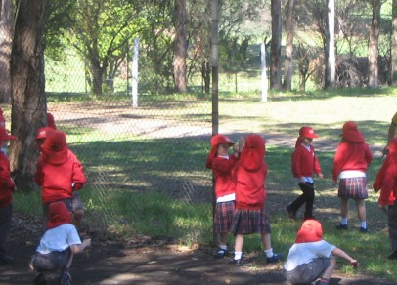 | 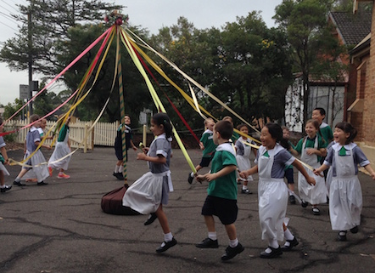 | 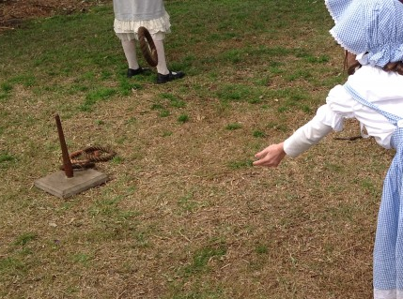 | 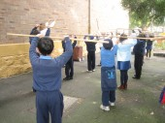 | 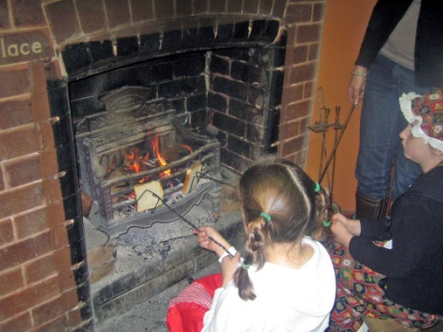
Playground - lunchtime and recess | Maypole dancing | Playing quoits | Wand drill using wands (poles) | Toasting bread over open fire | Writing with an ink pen

Risk rating matrix
Consequence criteria  How serious would it be | Likelihood criteria  How likely is it to occur
 | Very likely | Likely | Unlikely | Very unlikely
Extreme | 1 | 1 | 2 | 3
High | 1 | 2 | 3 | 4
Medium | 2 | 3 | 4 | 5
Low | 3 | 5 | 5 | 6

