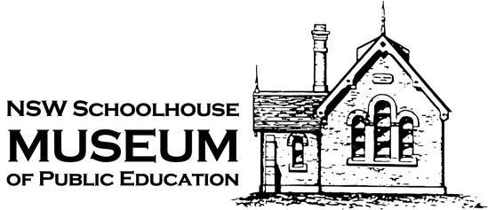

Social Story

Schoolhouse Museum
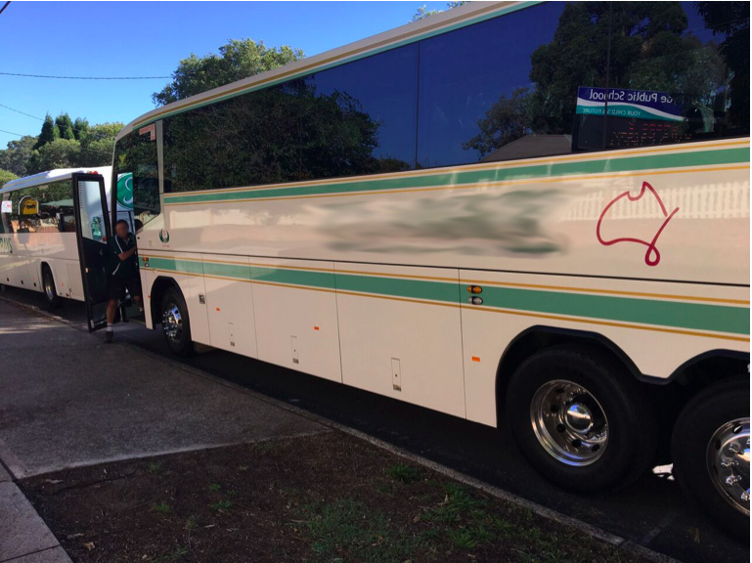
A bus will take you to the NSW Schoolhouse Museum at North Ryde.

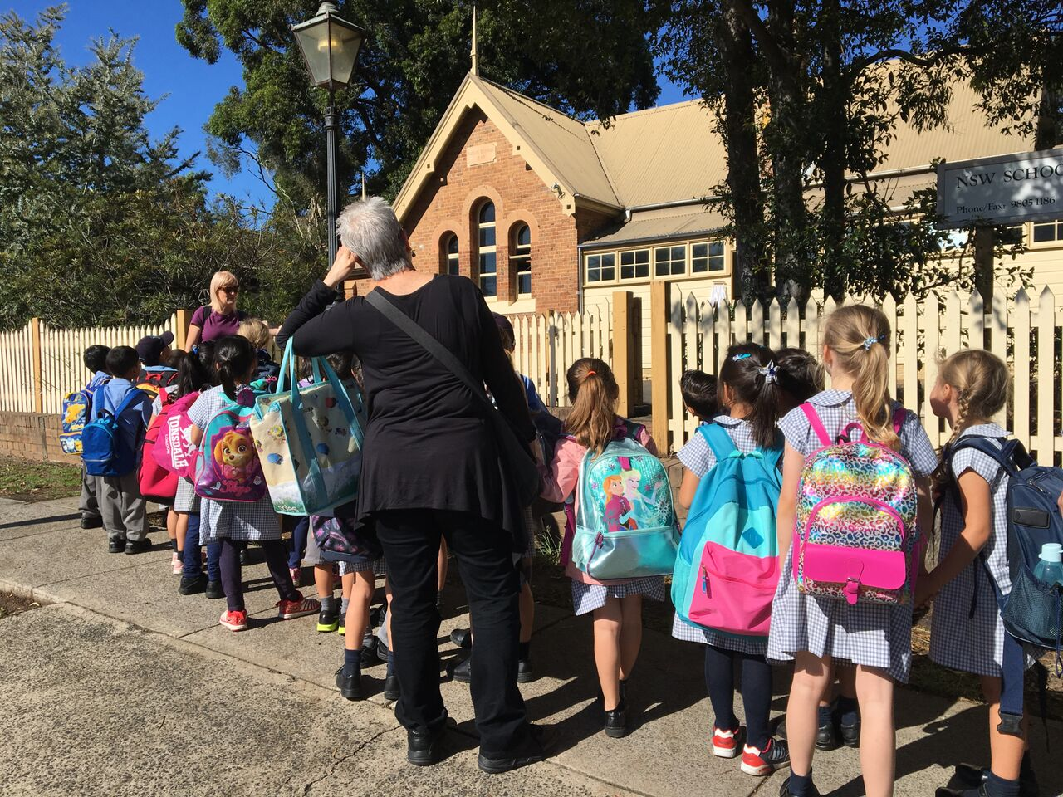

You will walk up the path and through a gate in the picket fence.

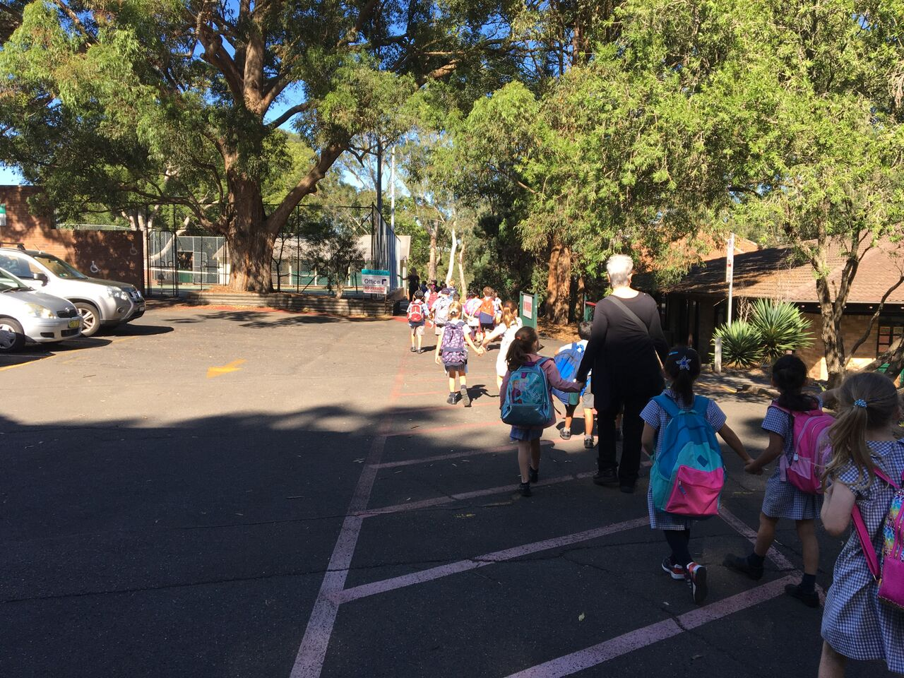

Your teachers will take you along the asphalt and past the school to have your recess.

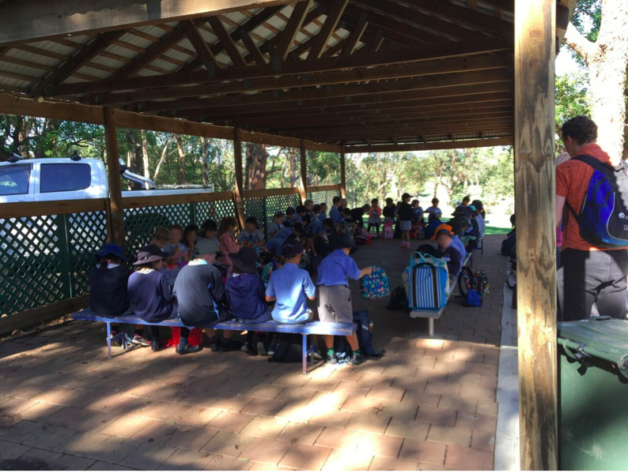

You will sit on the seats to eat your morning tea. You can use the toilets nearby.

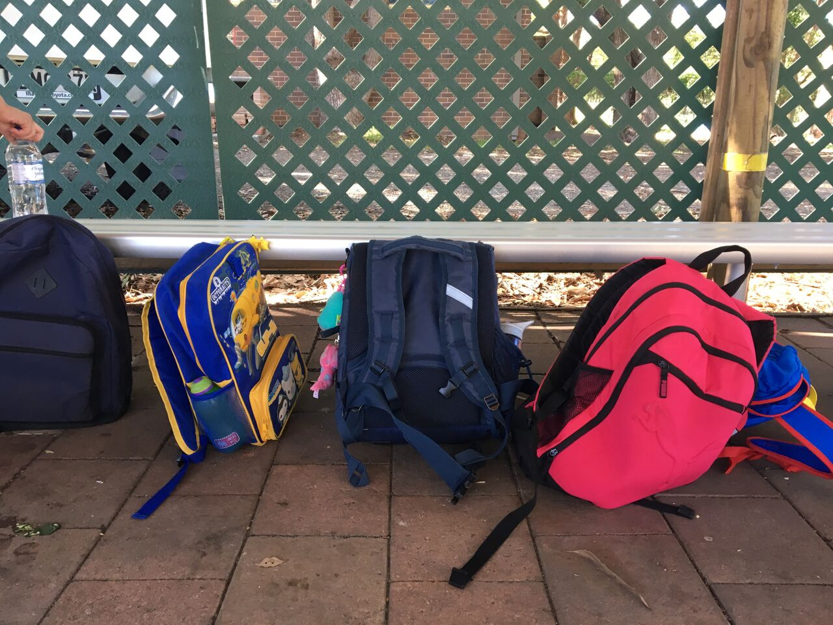

Your bag will be left at the seats. It will be safe. You will return here to have your lunch.

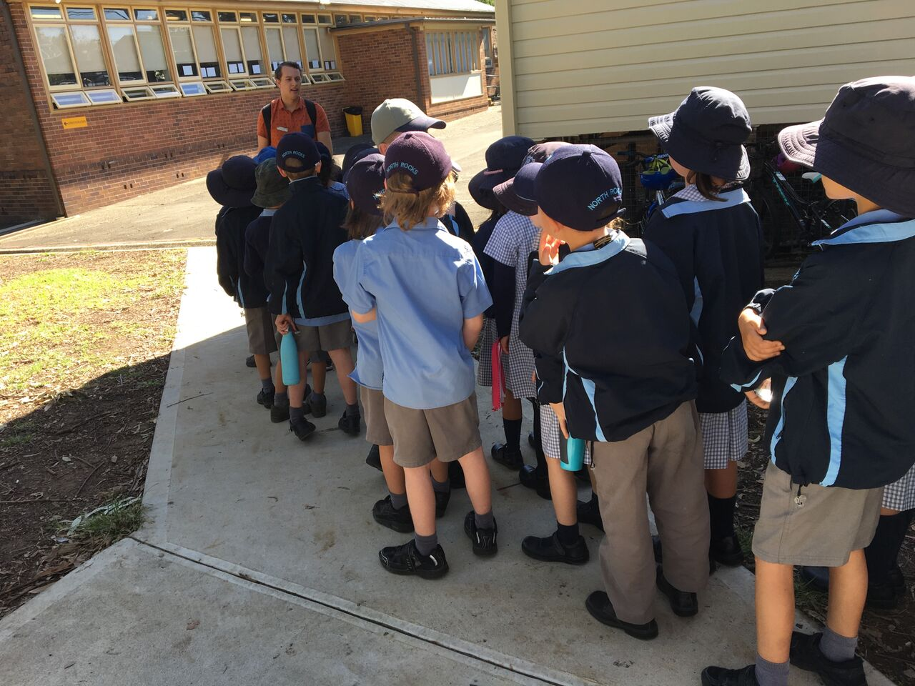

After recess your teacher will take you to your first museum activity.

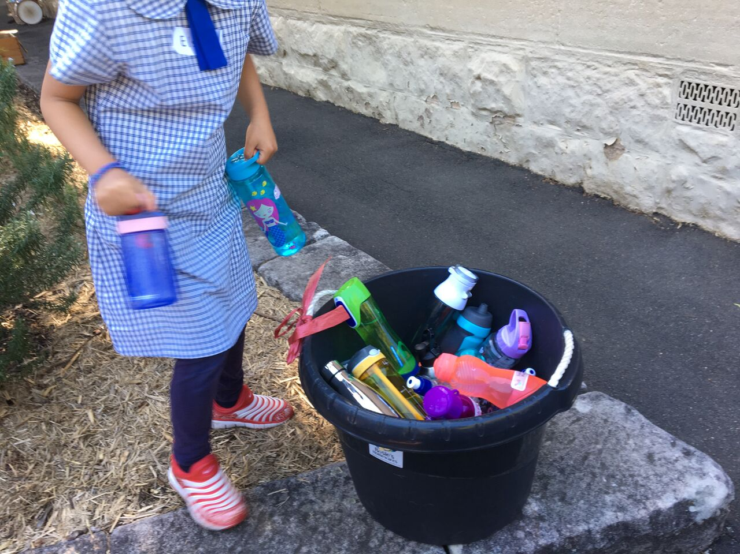

If it is a hot day you will bring your drink bottle. It will be safe in a tub.

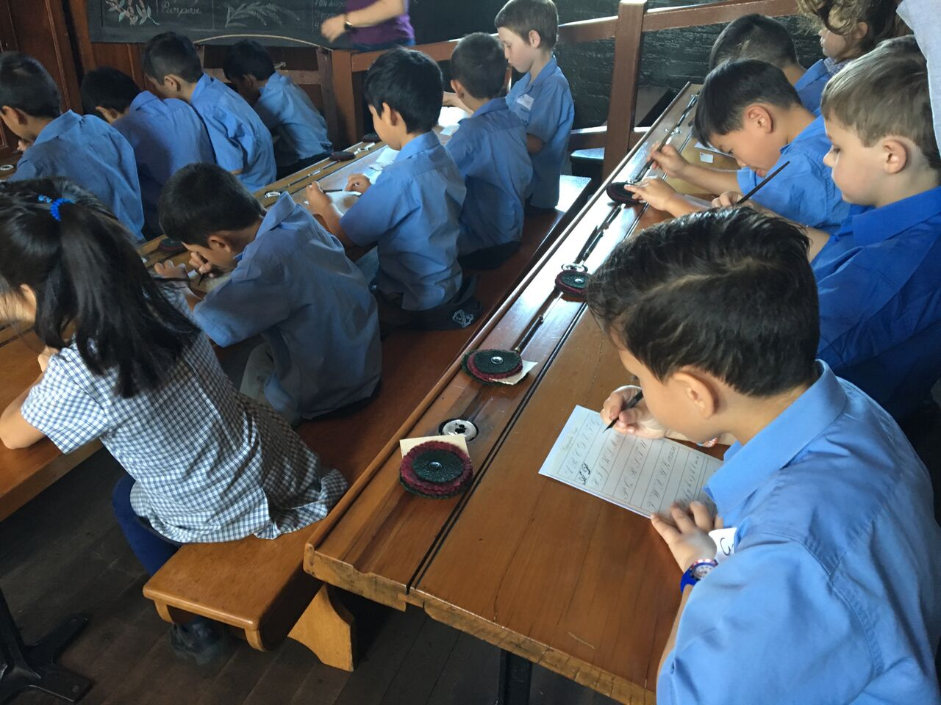

In the very old room you will sit on a bench at a long wooden desk.

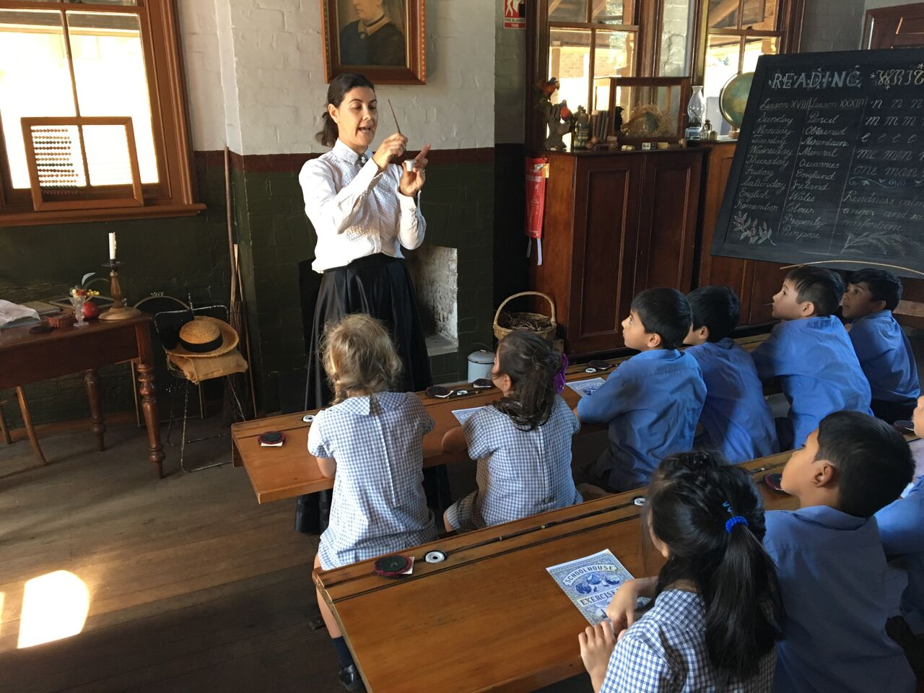

The teacher will explain how to use a slate pencil and an ink pen for writing.

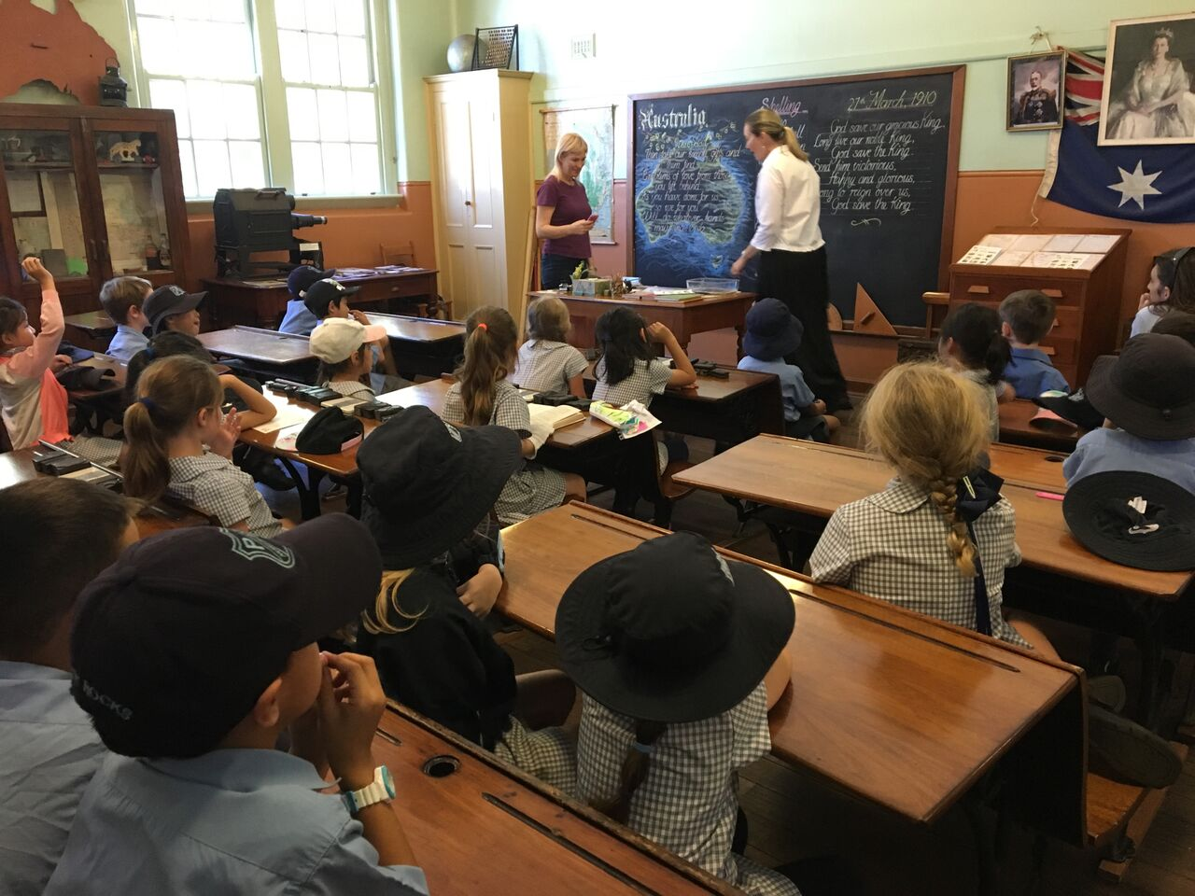

In the big room you will sit at a wooden desk while the teacher explains the activities.
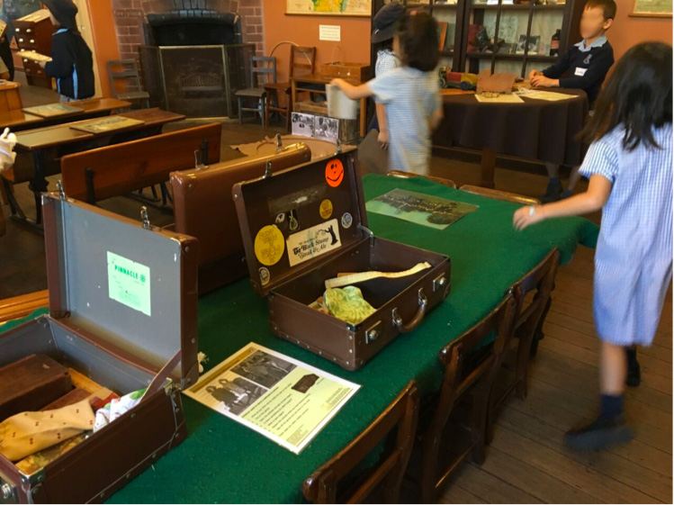

You will do lots of different activities. You can touch the suitcases and other objects.

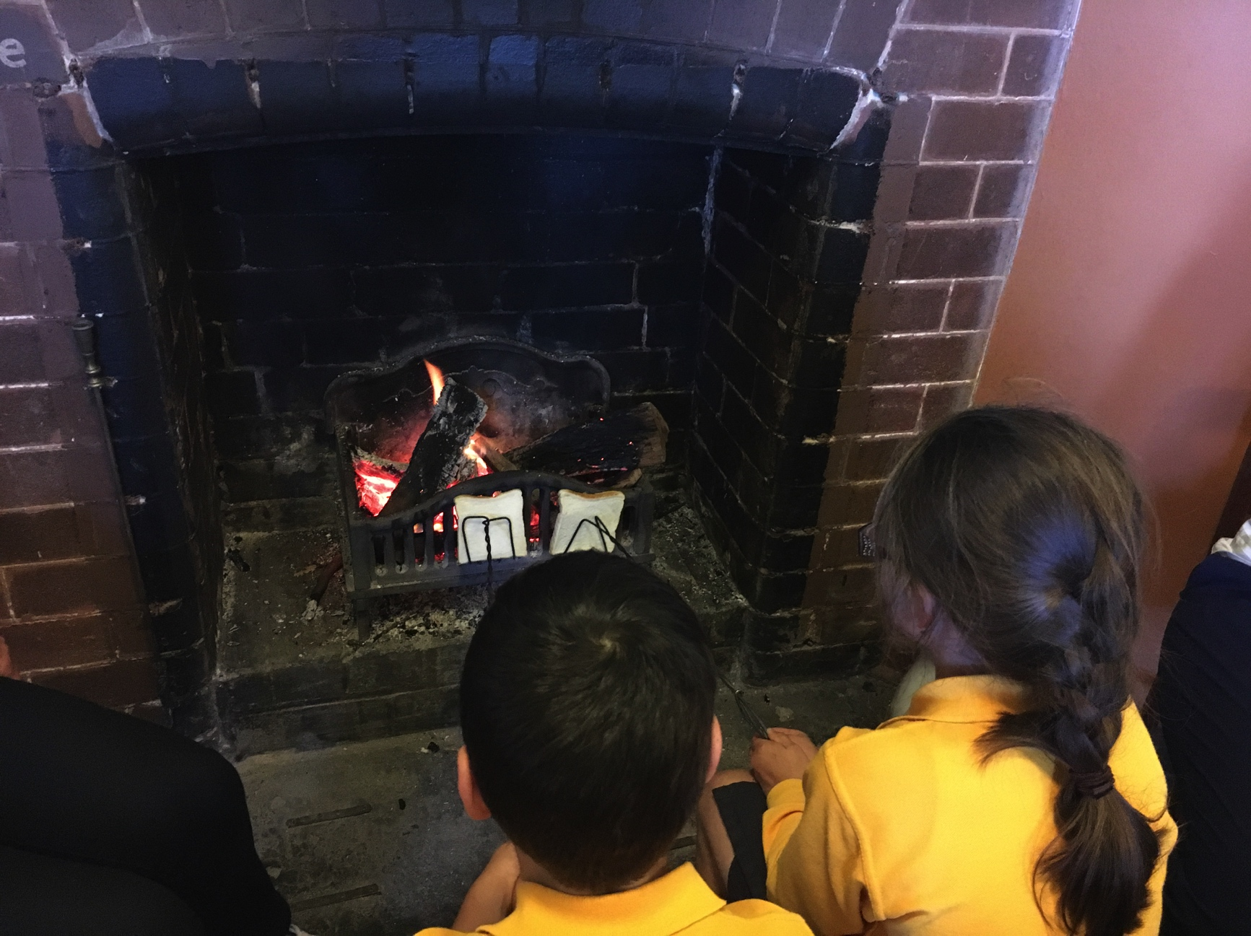

In winter time an adult will help you cook a piece of toast over the open fire.

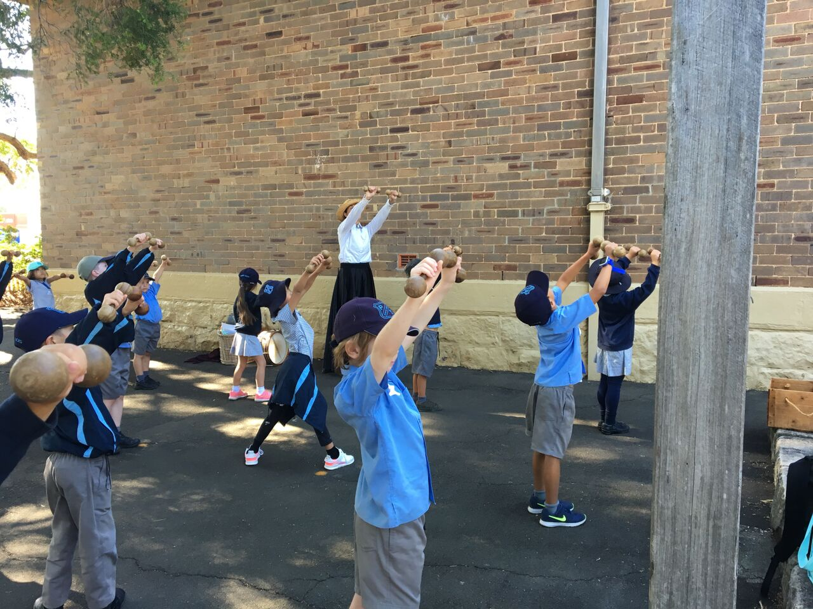

Outside you will hold dumbbells or a long stick to learn drill exercises.
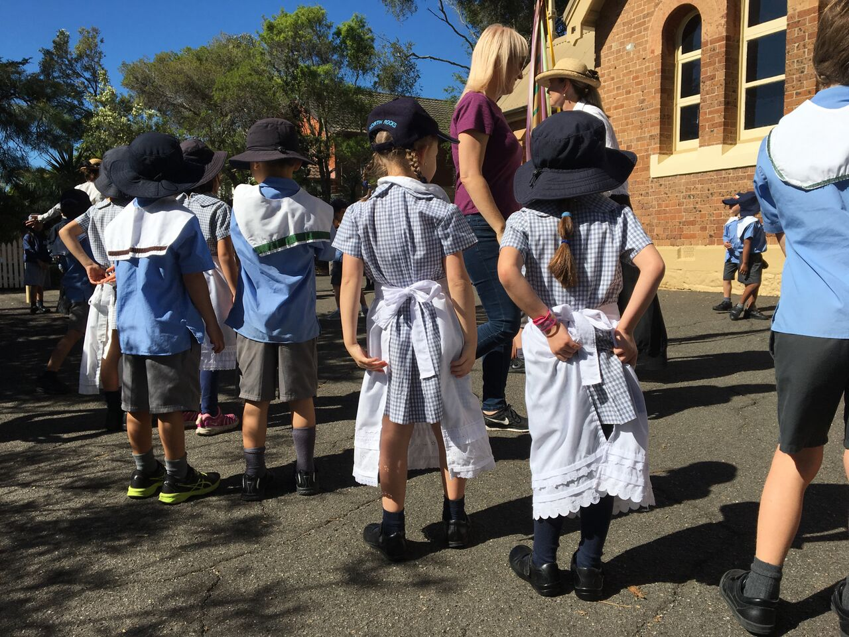

You will wear an apron or a sailor’s collar to do maypole dancing.
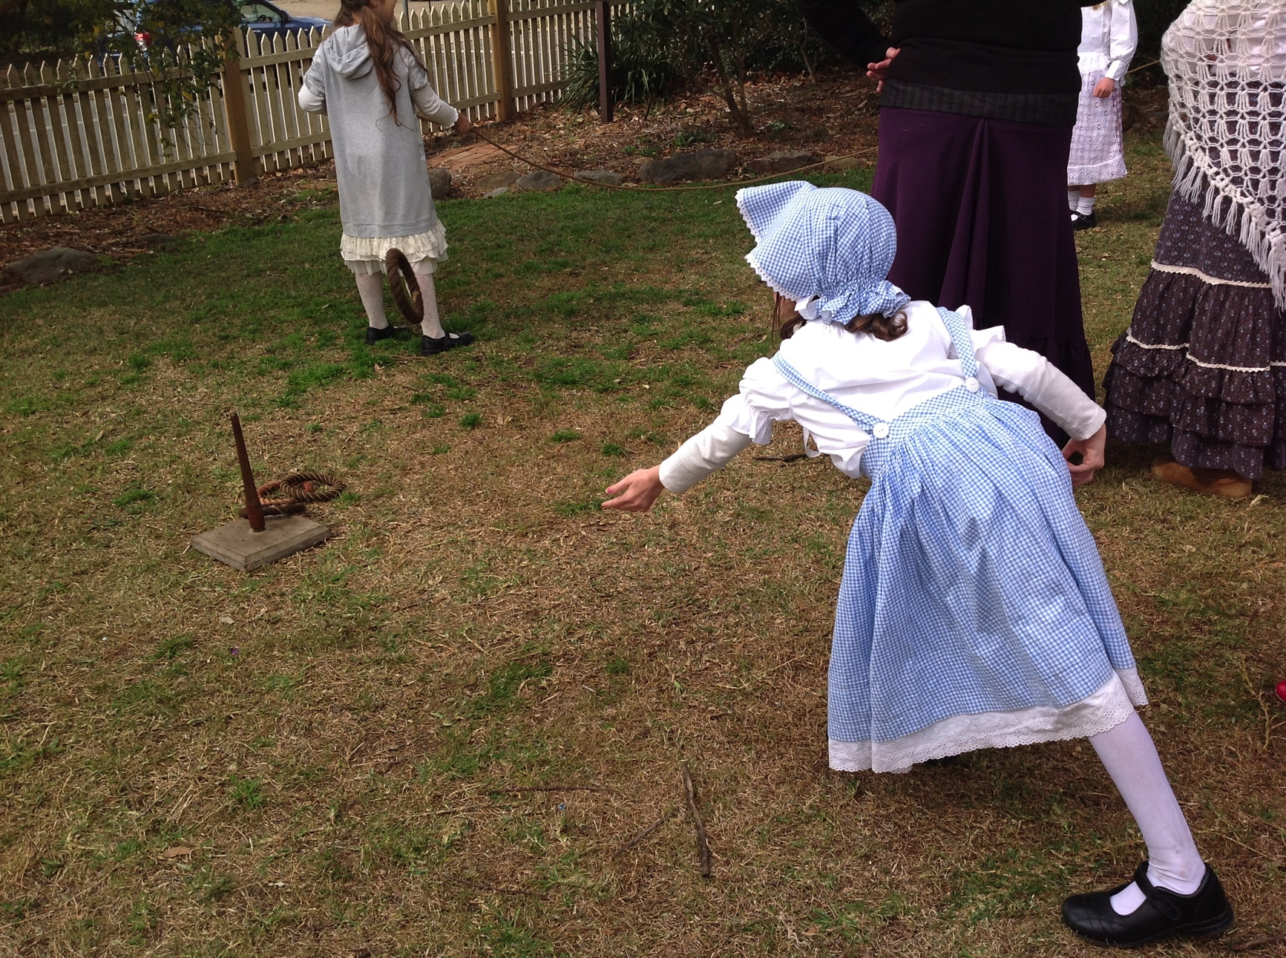

You will play some games such as quoits, skipping, hoops and fly.

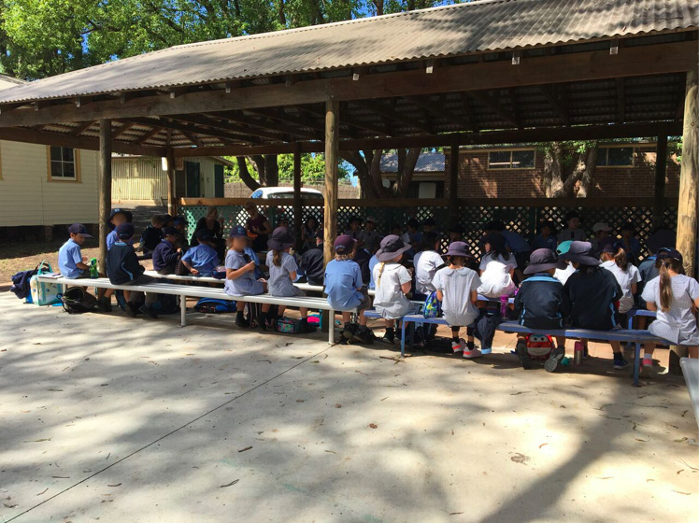

After the museum activities you will go to the seats to eat your lunch and use the toilet.

Your teacher will take you to the bus. The bus will take you back to school.

